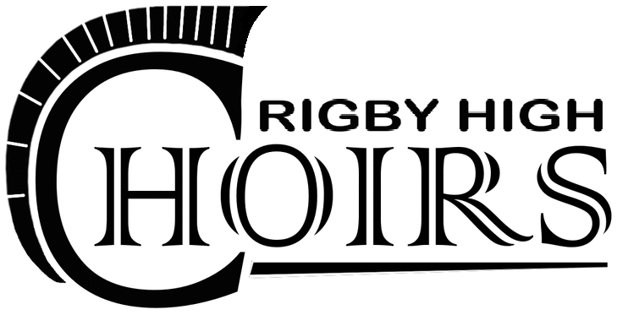

Syllabus 2015-2016

Teacher: Mr. Corbin Rasmussen

Phone: (208) 745-7704

Email: crasmussen@sd251.org

Course Objectives: Voice Mastery
The purpose of this course is to gain understanding of vocal production and the vocal mechanism, music fundamentals, and about performance skills as they apply to a variety of musical styles. All literature that is included in the curriculum is selected based on its place in music history, educational content, and vocal demand. Much of the standard solo music literature includes settings of religious texts, however, religious ideas are not taught in the classroom. Musical selections with religious texts are used to teach classic music history, style, concepts, and techniques.

Classroom Expectations:
- BE NICE!! Respect your teachers, your classmates, and yourself.
- Arrive at rehearsal/class on time. “On time” means you give yourself enough time to pick up your music folder, have a pencil ready, and are in your seat when the class is ready to begin.
- No food or drink allowed in the choir room during instructional time. Only exception is water in a closed container or bottle.
- No gum… EVER!! Gum is to be spit out at the beginning of class as you walk into the room. If you are caught chewing gum during class time you will lose daily participation points.

Grading Policy:
A | 94% - 100%
A- | 90% - 93%
B+ | 87% - 89%
B | 83% - 86%
B- | 80% - 82%
C+ | 77% - 79%
C | 73% - 76%
C- | 70% - 72%
D+ | 67% - 69%
D | 63% - 66%
D- | 60% - 62%
F | 0% - 59%
This class will require written homework and take home assignments. In addition, you are expected to practice your music at home for at least 15 minutes a day. For the most part however, your work is done in class by participating and being a responsible member of the class.

Assignments:
50% Summative Assessment
10% Written Quizzes
40% Recitals
40% Formative Assessment
25% Daily Work
10% Self-Assessments
5% Other Projects
10% Homework
4 Listening Assignments

Daily Work:
You will earn point’s everyday you come to class prepared and ready to participate fully in the day’s activities. You will lose points if you: goof off, distract fellow students, not sitting in assigned section/seat, excessive talking, coming to class unprepared, etc.

Recitals & Self Critiques:
You all will be required to participate on a bi-weekly basis in a vocal recital. In addition to being in the recital, you will also write an assessment of yourself for each recital. This paper must be typed, at least two paragraphs in length with one-inch margins, Times New Roman or Calibri 12 point font, double-spaced. The first paragraph will consist of thing you noticed about the overall growth of you as a performer. The second paragraph will consist of things you still would like to work on.
Things you should include in the first paragraph:
- Start with details such as what kind of song you chose and why.
- What aspects of singing were you specifically aware of/thinking about as you were performing this selection?
- Discuss successful musical elements and techniques about your performance.
Things you should include in the second paragraph:
- What worked and what didn’t work in your performance.
- What sort of things do you still need to work on?
- Discuss unsuccessful music elements and techniques that are talked about in class.
Critiques must be submitted in class.
Written Quizzes:
Throughout the duration of this course, you will be required to learn about the anatomy of the voice and will be introduced to the International Phonetic Alphabet (IPA). Written quizzes will be administered in class.
Listening Quizzes:
Every two weeks you will be required to listen to a musical selection of the current genre via the choir web page. You will be asked to respond to the listening example in various ways, including some of your overall impressions about the piece. On occasion a “listening quiz” may be administered in class that pertains to the online listening assignment for that two-week period.
Website and Information:
The official website for Rigby Choirs is choir.rigbytrojans.org. This site is continuously being improved and updated, and contains a calendar of all the choral events and performances for the school year. Additionally, other area concerts, assignments, project details, forms, practice recordings, etc., are posted online. Please review the calendar and your class page often.
Course Breakdown:
Unit One: American Art Song | Feb. 29 – Mar. 18 | Introduction to course, Introduction to Vocal Anatomy and Parts of the Body, Vocal Anatomy Quiz, 1st Master Class, 1st Recital, 1st Self-Assessment
Unit Two:  English Art Song | Mar. 28 – Apr. 8 | Introduction to International Phonetic Alphabet (IPA), IPA Quiz, 2nd Master Class, 2nd Recital, 2nd Self-Assessment
Unit Three:  Italian Aria | Apr. 11 – Apr. 22 | 1st Listening Assignment, Italian IPA Quiz, 3rd Master Class, 3rd Recital, 3rd Self-Assessment
Unit Four:  Spiritual/Gospel | Apr. 25 – May 6 | 2nd Listening Assignment, 4th Master Class, 4th Recital, 4th Self-Assessment
Unit Five:  Broadway | May 9 – May 20 | 3rd Listening Assignment, final Master Class,
Finals:  Final Performance | May 23 – May 26 | Final Recital, Final Self-Assessment

Please review and sign the accompanying form and return to Mr. Rasmussen by _______ / _______ / _______

I have read and understand the expectations of the Rigby High School Choir Program as outlined in the syllabus.

________________________________________________ ___________________________________________
^{Student Signature} ^{Date}

________________________________________________ ___________________________________________
^{Parent Signature} ^{Date}

